Create Templates in HIS

Step 1:
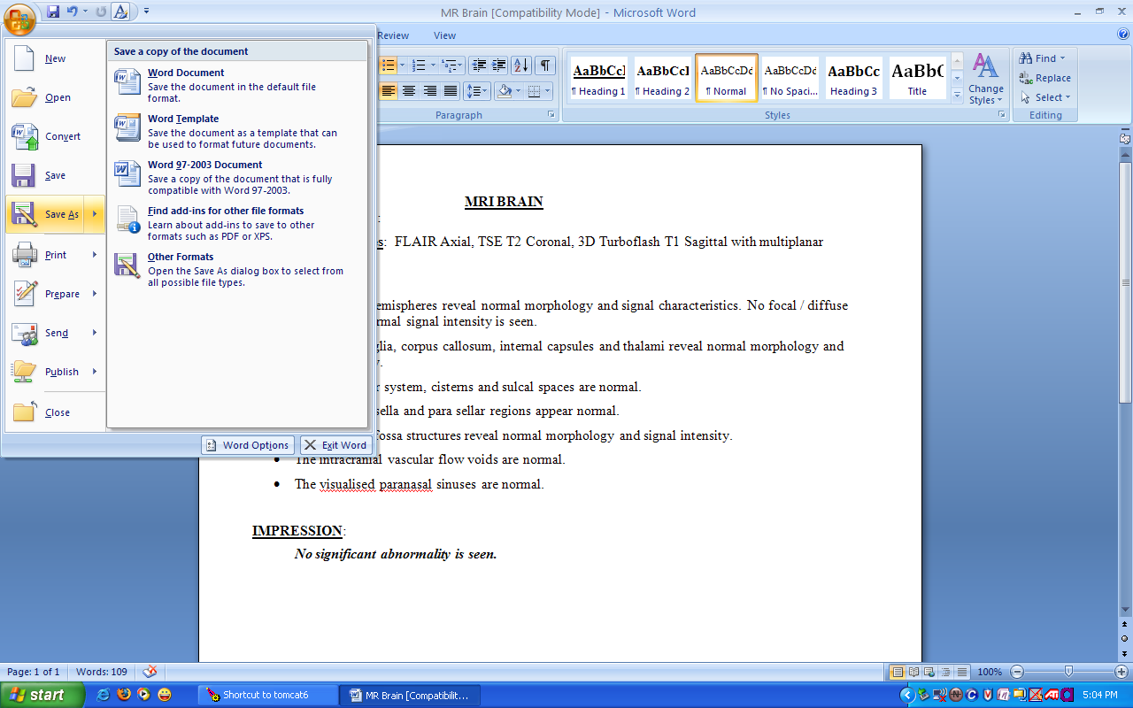

Create/Open new template in MS Word and click Save As icon then below screen will appear

Step 2:
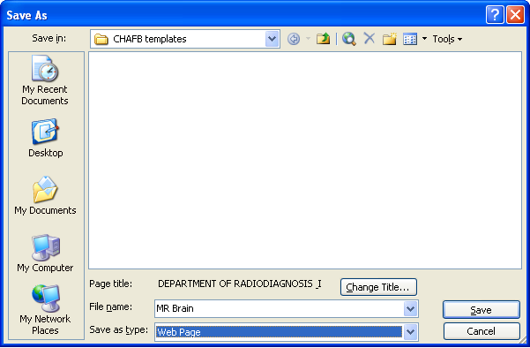

Save this file as Web Page then users can use this file in HIS Application

Dignostic Master In HIS
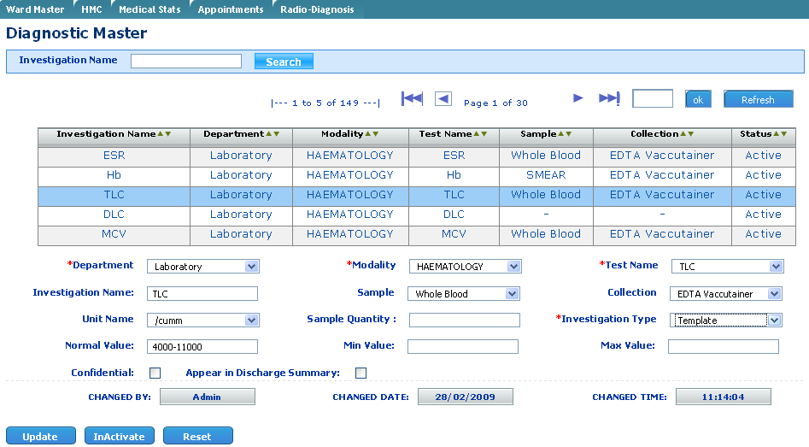

Any Investigation / Test use select Investigation type as template then below screen will open
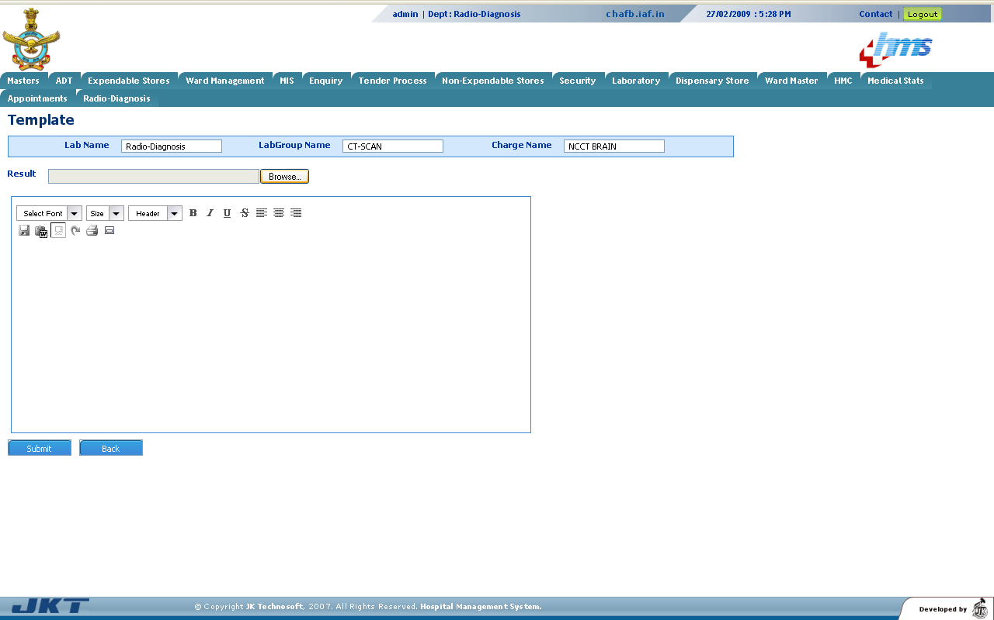

Now user can select saved file from Browse Button ten below screen will appear

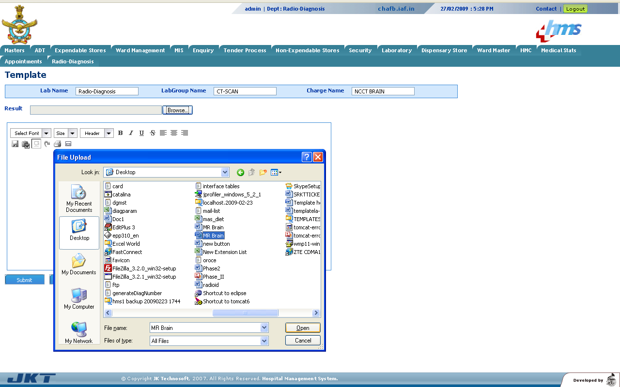

Now user can select saved file from folder then click open button
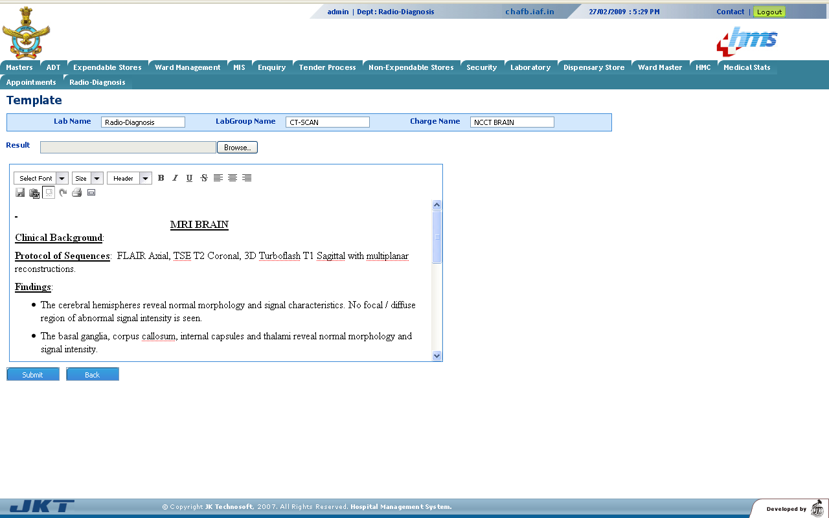
Then Submit button then template will save in HIS data base , User can use

